Title of the contribution

Presenting Author^{1*}, Second Author¹, Third Author¹, Last Author^{1,2}

¹Department 1, University X, City, Country,

²Department 2, University Y, City, Country
*mail@mail.com
Introduction [1].
More text [2].
Conclusion.

References
[1] A.P. Jones, X. Kang, Nature Materials 3, 444 (2006)
[2] Z. Y. Zhu, Y. C. Cheng, and Y. Chen, Phys. Rev. Lett. 23, 1234546 (2000)

Figures
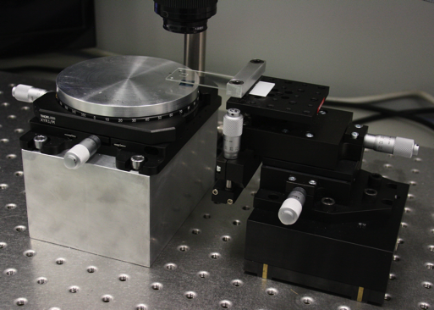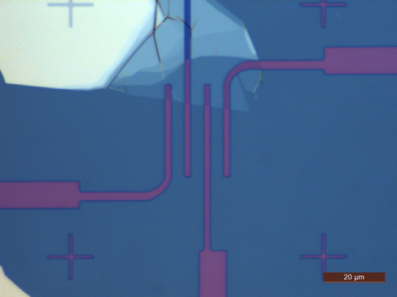
Figure 1: LEFT: Picture of the stamping setup at CIC nanoGUNE. RIGHT: Optical image of a top-contacted monolayer MoS₂

